<!DOCTYPE html>

<html lang="en">

<head>

    <meta charset="UTF-8">

    <meta name="viewport" content="width=device-width, initial-scale=1.0">

    <title>Document</title>

    <style>

        body{

            margin-left: 400px;

            margin-top: 20px;

                        }

        table{

            width: 60%;

            height: 250px;

            padding: 2px;

            border:1px solid#7ab3a2;

        }

        caption{

            font-weight: bold;

        }

    </style>

</head>

<body>

    <table border="6">

    <caption style="margin-bottom: 20px;">Basic Course </caption>

    <tr style="background-color: yellow;">

        <th>Sr.No</th>

        <th>Course Name</th>

        <th>Fees</th>

        <th>Duration</th>

        <th>Eligibility</th>

       </tr>

       <tr>

        <td>1</td>

        <td>CCC - Course on Computer Concept</td>

        <td>2000</td>

        <td>3 Months</td>

        <td>10<sup>th</sup></td>

       </tr>

       <tr>

        <td>2</td>

        <td>CCA - Course on Computer Application</td>

        <td>2000</td>

        <td>3 Months</td>

        <td>10<sup>th</sup></td>

       </tr>

       <tr>

        <td>3</td>

        <td>Tally</td>

        <td>3000</td>

        <td>3 Months</td>

        <td>10<sup>th</sup></td>

       </tr>

       <tr>

        <td>4</td>

        <td>O Level</td>

        <td>15,000</td>

        <td>1 Year</td>

        <td>12<sup>th</sup></td>

       </tr>

       </table>

</body>

</html>

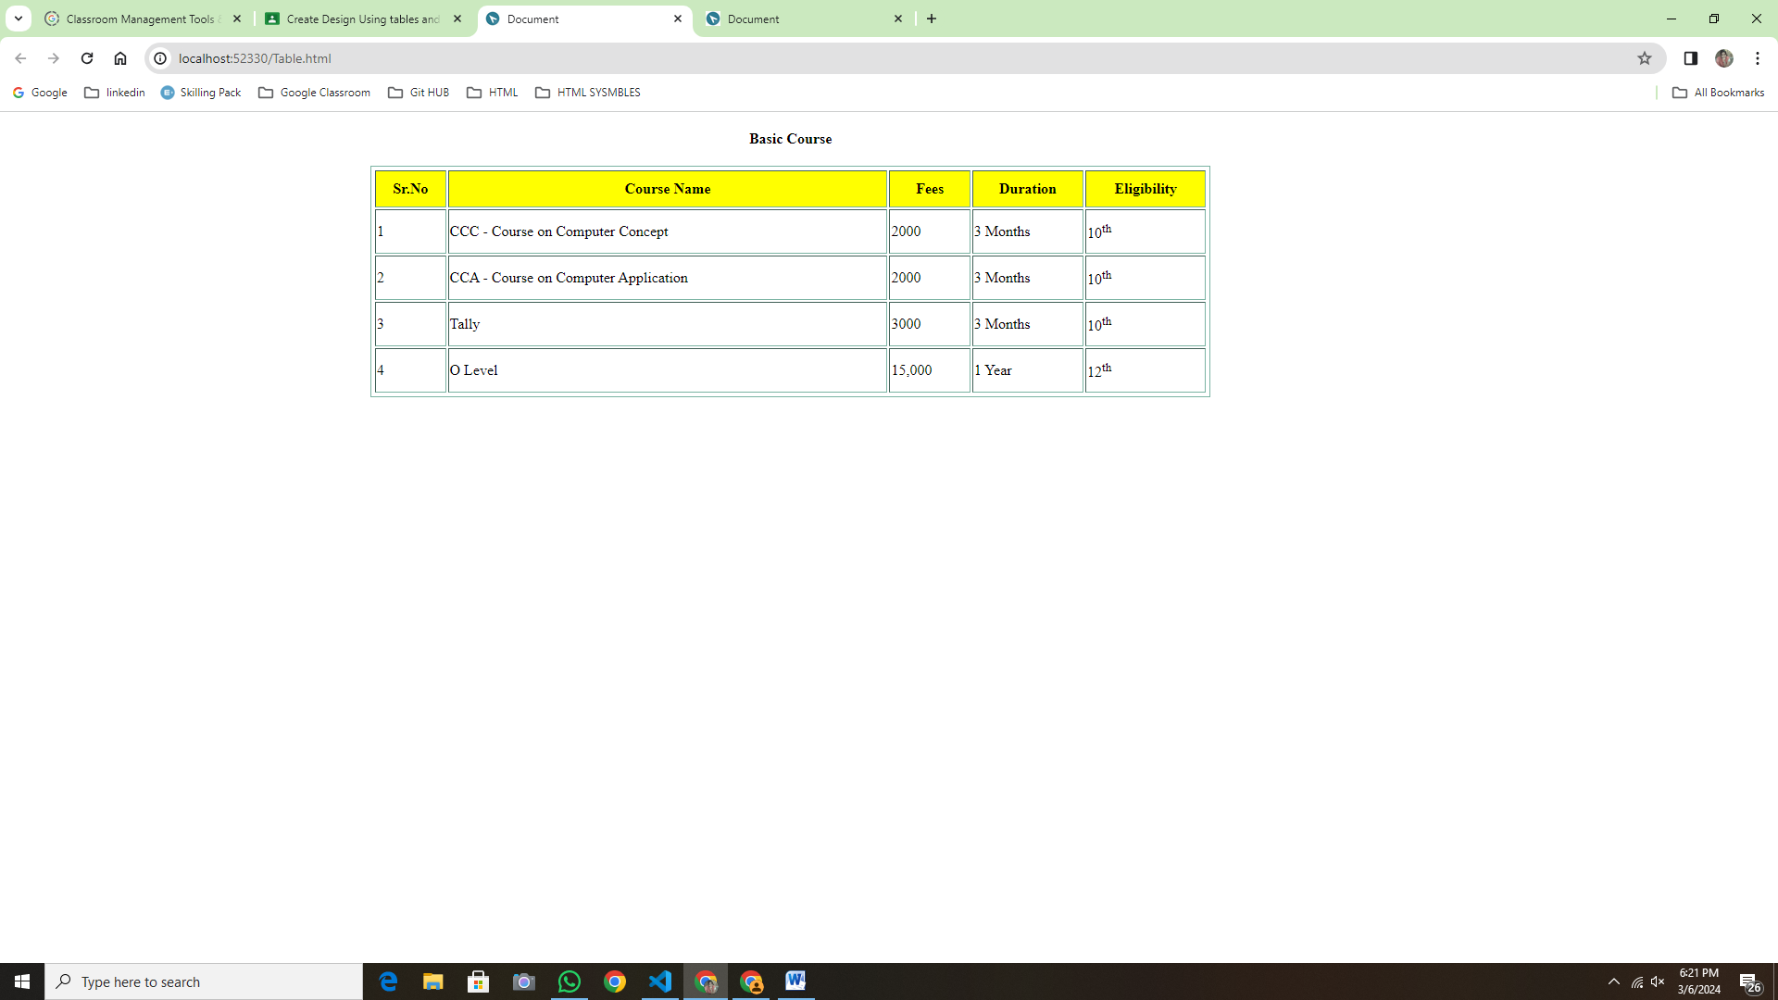

<!DOCTYPE html>

<html lang="en">

<head>

    <meta charset="UTF-8">

    <meta name="viewport" content="width=device-width, initial-scale=1.0">

    <title>Document</title>

</head>

<body>

    <h1>Input/Output Devices</h1>

    <dl>

        <dt>Mouse</dt>

        <dd>Mouse is input device and also known as pointing device.</dd>

        <dt>Printer</dt>

        <dd>Printer is Output device which provide hard copy of output.</dd>

        <dt>Monitor</dt>

        <dd>Monitor is output devices which provide sofr copy of output.</dd>

    </dl>

</body>

</html>

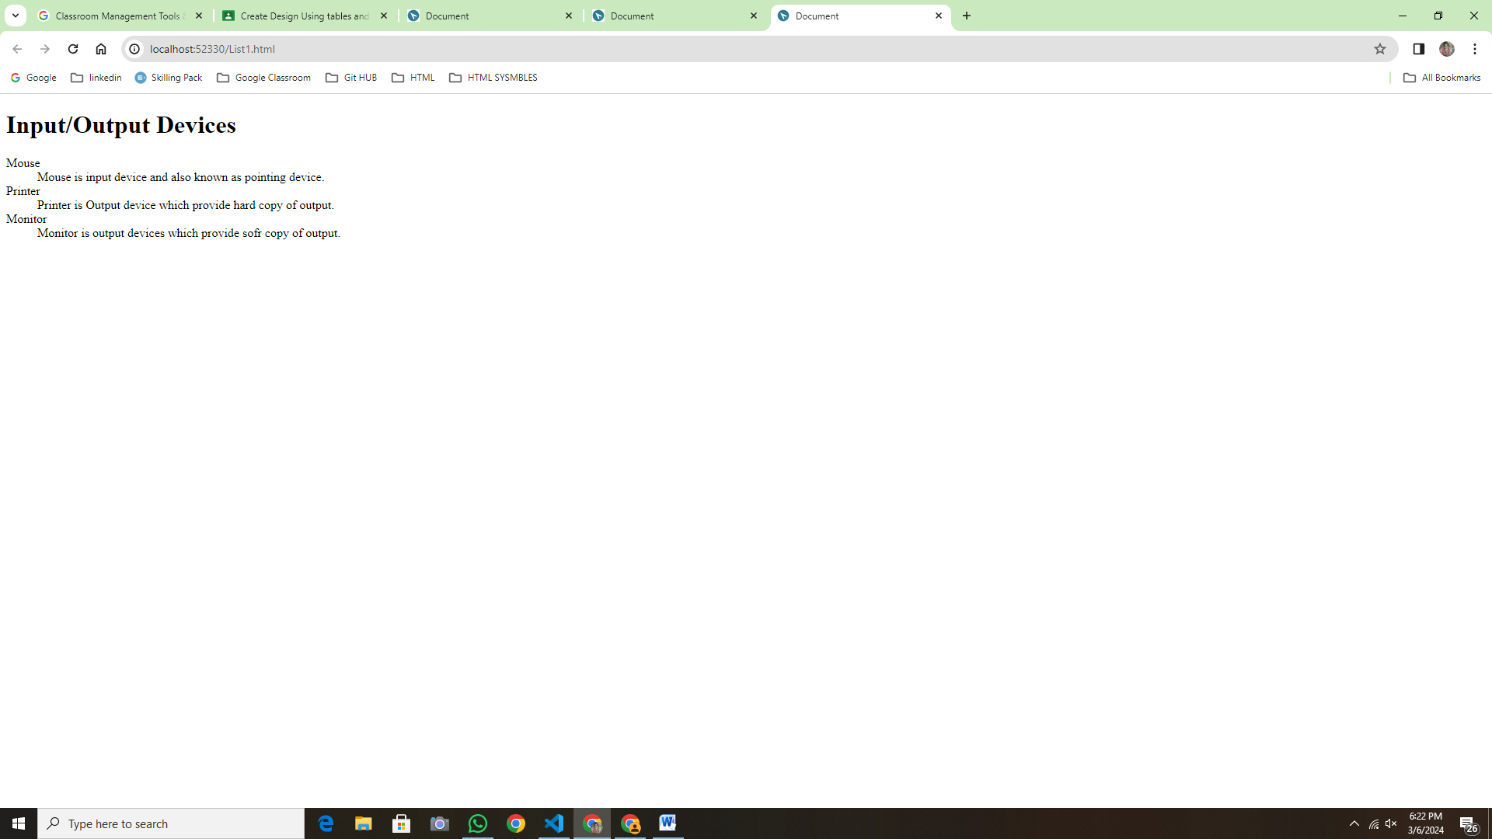

<!DOCTYPE html>

<html lang="en">

<head>

    <meta charset="UTF-8">

    <meta name="viewport" content="width=device-width, initial-scale=1.0">

    <title>Document</title>

    <style>

        table{

            margin:auto;

            width: 800px;

            height:20px;

            border:10px solid rgb(146, 180, 179);

            border: rgb(128, 166, 180);

        }

        th,td{

            font-size: 20px;

            padding:px;

        }

    </style>

</head>

<body>

    <table border="2">

        <tr>

            <th colspan="2>">Registration form</th>

        </tr>

            <tr>

        <td><label> Student Name</label></td>

        <td><input type="text" Student name="Value=" required></td></tr><br>

        <td><label> Father's Name</label></td>

        <td><input type="text" Father's Name="Value=" required></td></tr><br>

        <td><label> Mother's Name</label></td>

        <td><input type="text" Mother's Name="Value=" required></td></tr><br>

        <tr><td><label>Date of Birth:</label></td>

            <td> <input type="date" name="Phoneno" value=""  placeholder="dd/mm/yyyy"

              required></td></tr><br>

            </select></td> </tr><br>

            <tr> <td><label>Gender</label></td>

          <td> Male<input type="radio" name="sex" value="Male"> Female

            <input type="radio" name="sex" value="Female"></td> </tr><br>

         <td><label>Email id</label></td>

         <td><input type="text" Email id></td>

         <tr><td><label>Phoneno:</label></td>

            <td> <input type="number" name="Phoneno" value=""

                required></td></tr><br>

                <tr><td><label>Address:</label></td>

                    <td> <textarea rows="5" cols="20"  placeholder="Address"></textarea></td> </tr><br>

                    <td><label> State</label></td>

                   <td><input type="text" State="Value=" required></td></tr><br>

                   <td><label> City</label></td>

                   <td><input type="text" State="Value=" required></td></tr><br>

                </td></tr> <br>

                <tr><td></td>

                    <td><input type="submit"></td>

                </tr>

    </table>

</body>

</html>

